**1. What do we mean by AutoComplete feature in Excel and what are the benefits of using this feature?**

AutoComplete is the automatic filling in of our text when we start typing and is switched on by default. This will reduce the amount of text we have to enter by preventing we typing in repetitive words. AutoComplete matches only exact cell entries, not individual words in a cell. This does not work when entering or editing formulas. Autofill saves users from re-typing information. Minimize user input errors.

**2. Explain working with workbooks and working with cells.**

A workbook is a spreadsheet program file that we create in Excel. A workbook contains one or more worksheets. A worksheet (also known as a spreadsheet) consists of cells in which we can enter and calculate data.

Create a workbook

• Open Excel. • Select Blank workbook or press CTRL+N. • Start typing.

Create a workbook from a template

• Select File > New. • Double-click a template. • Click and start typing.

Cells are the boxes we see in the grid of an Excel worksheet, like this one. Each cell is identified on a worksheet by its reference, the column letter and row number that intersect at the cell's location

• To select a cell:

To input or edit cell content, we'll first need to select the cell.

• Click a cell to select it.

• A border

• will appear around the selected cell, and the column heading and row heading will be highlighted. The cell will remain selected until we click another cell in the worksheet.

**3. What is fill handle in Excel and why do we use it?**

Fill Handle is a feature in Excel that enables we to auto-complete a list in a row/column by simply dragging it using our mouse. A basic understanding of fill handle in Excel could save we some time and make we more productive.

The Fill Handle is an Excel feature that enables us to bypass the copy and paste of each value into cells and uses patterns instead of filling out the information. This tiny cross is a versatile tool in the Excel suite to perform data entry, transformation, and many other applications.

**4. Give some examples of using the fill handle.**

Fill Handle' is a tool that you can use to autocomplete lists in Excel. For example, if you have to enter numbers 1 to 20 in cell A1:A20, instead of manually entering each number, you can simply enter the first two numbers and use the fill handle to do the rest

**For example:** Let's enter 2 in cell B2 and 4 in cell B3. Next, we will implement a fill handle by selecting both the cells and dragging the cross (+) sign to the following cells. You will notice that Excel will automatically update the cells by incrementing 2 in each value.

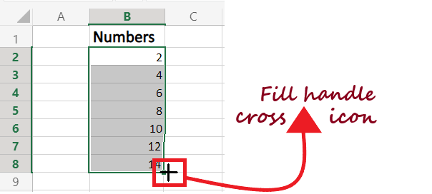

**5. Describe flash fill and what the different ways to access the flash fill are.**

Flash Fill automatically fills your data when it senses a pattern. For example, you can use Flash Fill to separate first and last names from a single column, or combine first and last names from two different columns.

Enter the full name in cell C2, and press ENTER.

Start typing the next full name in cell C3. Excel will sense the pattern you provide, and show you a preview of the rest of the column filled in with your combined text.

To accept the preview, press ENTER.

Concatenate data with Flash Fill

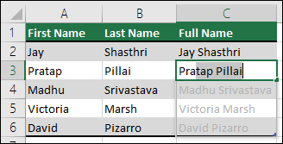

If Flash Fill doesn't generate the preview, it might not be turned on. You can go to Data > Flash Fill to run it manually, or press Ctrl+E. To turn Flash Fill on, go to Tools > Options > Advanced > Editing Options > check the Automatically Flash Fill box.